Simulating Periodic Payments Completion - Full Answer
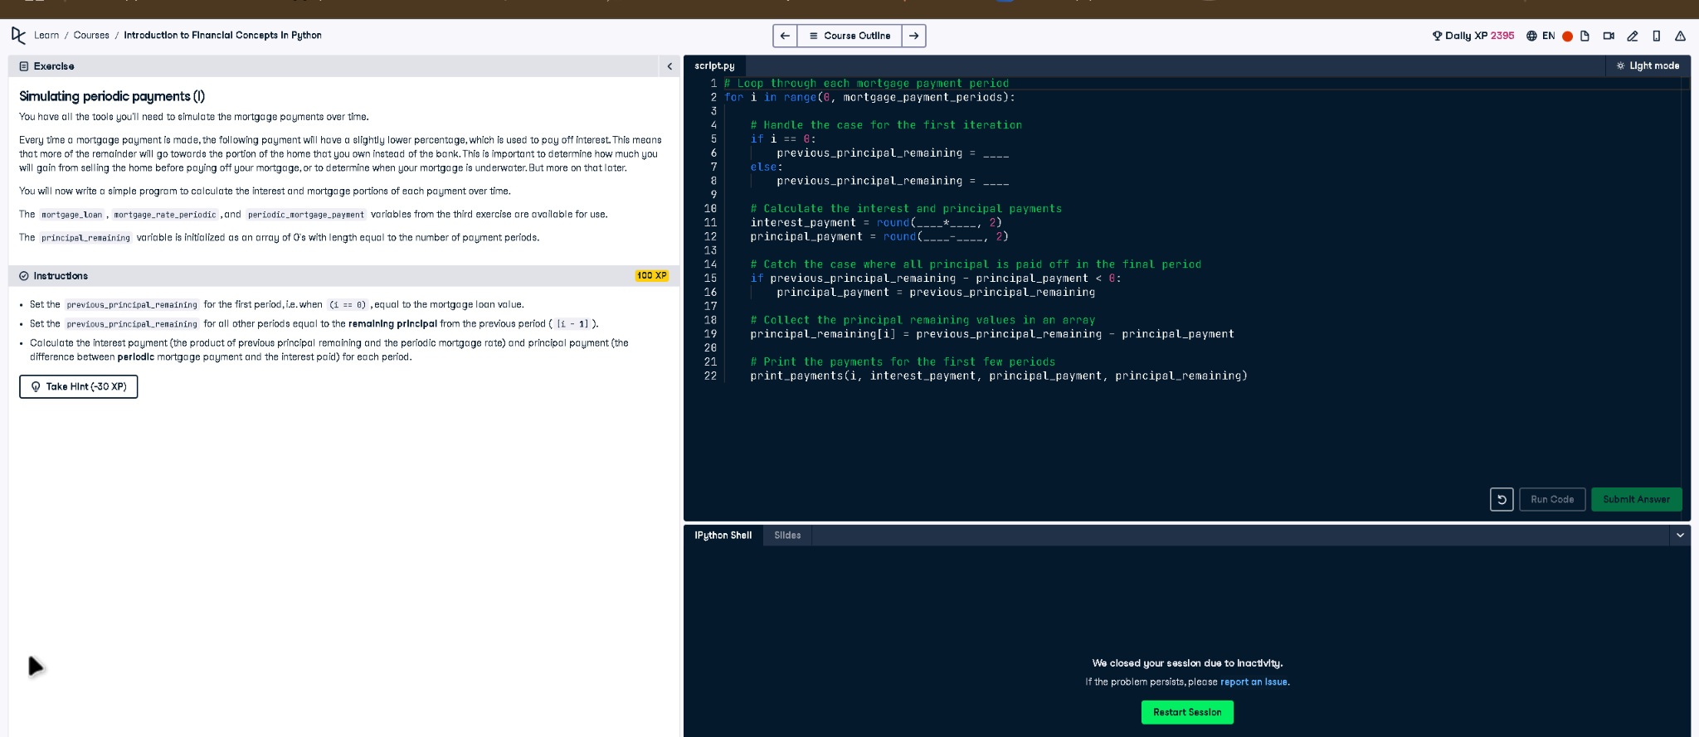

Full Code Answer:
# Loop through each mortgage payment period
for i in range(0, mortgage_payment_periods):
# Handle the case for the first iteration
if i == 0:
previous_principal_remaining = mortgage_loan
else:
previous_principal_remaining = principal_remaining[i - 1]
# Calculate the interest and principal payments
interest_payment = round(previous_principal_remaining * mortgage_rate_periodic, 2)
principal_payment = round(periodic_mortgage_payment - interest_payment, 2)
# Catch the case where all principal is paid off in the final period
if previous_principal_remaining - principal_payment < 0:
principal_payment = previous_principal_remaining
# Collect the principal remaining values in an array
principal_remaining[i] = previous_principal_remaining - principal_payment
# Print the payments for the first few periods
print_payments(i, interest_payment, principal_payment, principal_remaining)

Question:
How do you fill the missing values to simulate interest and principal payments for periodic mortgage payments?

20-word Explanation (Question):
To simulate periodic mortgage payments, track remaining principal, calculate interest from it, and determine the principal portion each period.

Answer:
Set first iteration's principal to mortgage_loan, subsequent to previous principal, then compute interest and principal payments accordingly.

20-word Explanation (Answer):
We update previous_principal_remaining each iteration, calculate interest as principal * rate, then subtract to find principal payment each period.

